Aarti Paan, Dhruti Pandya, Matthew Posa, and Chuhui Qiu

Professor Morris Lancaster

CS6461 Section 10 Spring 2022

06 February 2022

**Group Project Phase 1 Design Note**

This design note documents the structure of the simulator project, the classes, methods, functions, and data structures implemented, as well as any external dependencies used for this project.

# General Structure

The project consists of six source code modules separated into six python scripts, one compiled executable file, one User Guide document, and one Design Note document.

***Executable File.* CSCI6461_Project_main.exe** is the main file built for an x86_64 Windows machine. It is built using the command “pyinstaller --onefile CSCI6461_Project_main.py” and includes all six python scripts as well as any external dependencies.

***Main.* CSCI6461_Project_main.py** is the script that serves as the entry point for running the program, it can either be imported as a library or run directly to start the program.

1. Imports: the script imports module CSCI6461_Project_gui_interface and CSCI6461_Project_data from the other files, no external dependencies are imported.
2. The script defines one function “main()”, it takes no arguments and does not return; its function is to initialize the memory data, open the GUI interface, and enter a loop, in which it will accept any user input into the Python terminal and attempt to execute it with exec().
3. Global variables from globals() and “data” from CSCI6461_Project_data are used as locals for exec(); Exceptions are caught and merely printed then ignored.
4. Safety: the Python terminal is used as an engineer’s field console, and as a result no security measure is in place. It is totally possible to execute “rm -rf” there, so users should know what they are doing before attempting dangerous operations.

***GUI Classes.* CSCI6461_Project_classes.py** is the script containing definitions for the primary GUI elements: bit, bitString, and labeledBitString, and their related interface methods. It can be imported as a GUI library.

1. Imports: the script imports the external module “tkinter” and its submodule “ttk”, both are built-in to Python 3.7.
2. Bit Class: the fundamental class for a single button that acts as a single-bit register, it holds a single number 0 or 1 to show its content.
3. Method __init__(self, value=0) initializes an instance of a Bit by setting three properties.

i. “btn” for holding a ttk.Button instance

ii. “trigs” for holding a dictionary of functions to be triggered

iii. “v” for holding a binary value, optionally specified by the “value” parameter.

1. Method create(self, frame, x=0, y=0, **kwargs) creates the actual button onto a Tkinter frame, it would optionally take positional arguments x and y, and any additional keyword-ed arguments that are accepted by ttk.Button(), the Bit instance must have been initialized first.
2. Method destroy(self) destroys said button, allowing it to be recreated.
3. Methods value(self) and value_get(self) returns the binary bit stored within the instances as an integer.
4. Method value_set(self, value=0, trigger=True) may be called to set the binary value stored in the instance to 0 or 1; an optional boolean “trigger” parameter is used to specify whether this update will cause the “trigs” dictionary of functions to be called.
5. Method flip(self) toggles the value stored in the instance between 0 and 1.
6. Method update(self, trigger=True) reconfigures the text on the button to reflect its current value; if the boolean “trigger” parameter is true, each function within the “trigs” dictionary will be called.
7. BitString Class: a continuous “string” of Bit instances to represent a multi-bit register 
8. Method __init__(self, count=1) works similar to that for the Bit class, but instead of setting an initial value, all Bit instances are assumed to be 0, and its length is set by the parameter “count”.
9. Method create(self, frame, x=0, y=0, toggleAble=True, **kwargs) works similar to that for the Bit class, with an additional argument “toggleAble” for configuring whether the instances can be clicked and toggled.
10. Method destroy(self), update(self,trigger=True), value(self), value_get(self), value_set(self, value, trigger=True) works the same way as Bit, except value_set() now configures the string of bits to be the Big-Endian, binary representation of the given integer “value”, if the value cannot be fully represented due to overflowing or negative input, the nearest binary representation will be taken and the remainder will be returned as an integer.
11. bitStyle(self, **kwargs) is a shorthand way to quickly configure all buttons within the Bit instance to the same ttk style. This function is currently unused.
12. LabeledBitString class: a class inheriting the BitString class, it additionally holds up to three ttk label widgets for displaying the name and value of the register it represents.
13. Method __init__(self, value=0) initializes the instance similar to BitString, and also initializes three properties holding ttk label widgets.

i. “labelTxt” for holding the name of the instance.

ii. “labelHex” for holding a hexadecimal representation of the value of the instance.

iii. “labelTen” for holding a decimal representation of the value of the instance.

1. Method create(self, frame, text="", x=0, y=0, gap=0, toggleAble=True, numLabels=True, **kwargs) places the instance onto a Tkinter window; besides the normal parameters explained above, it also includes “text” to specify the name of the instance, integer “gap” to place before the buttons for widget alignment, and whether the numeric representation labels should be generated.
2. Method text_set(self, text="") sets labelTxt to the newly given string of text.
3. Method destroyLabel(self, label) removes a particular given label from the Tkinter window, this is mainly used as a helper function for destroy(self).
4. Method destroy(self) and update(self, trigger=True) works similarly to that of the other two classes. One addition is that update() now also updates the numeric representation labels of the instance to reflect the new number whenever they change.

***Interface GUI.* CSCI6461_Project_gui_interface.py** is the script containing definitions for creating the main GUI window of the program. It can be imported as a GUI library.

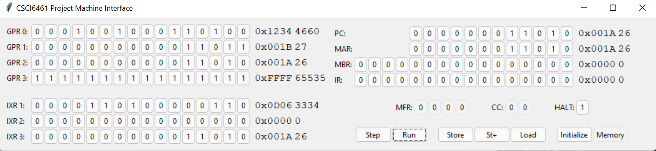

1. Imports: the script imports the external module “sys”, “tkinter” and its submodule “ttk”, both are built-in to Python 3.7. And some other libraries written and defined further in the program such as “CSCI6461_Project_classes”, “CSCI6461_Project_gui_memory”, “CSCI6461_Project_execution” & “CSCI6461_Project_data”.
2. The function def guiInterface() creates a main GUI window of our project. The data['windowInterface'] is used to create the main GUI window of our program named “windowInterface” & titled as “CSCI6461 Project Machine Interface”. When the window is closed, sys.exit() is called to exit the program.
3. This main window is further split into two further frames: “registersGPRFrame” on the left and “controlsFrame” on the right.
   1. Frames are created using the sub module ttk and placed using module grid.
   2. Positions are defined as per x(column) and y(row).
   3. x=0,y=0 is the top left, going right/down is the positive x/y direction
4. Further data['registersGPRFrame'] creates a “registersGPRFrame” containing general purpose registers and index registers. There are four 16-bit GPRs and three 16-bit IXRs.
   1. Four GPRs are located from (X=0) & (Y=0) to (X=0) & (Y=3). Using a for loop all the GPRs of 16 bits are created.
   2. Three IXRs are located from (X=0) & (Y=5) to (X=0) & (Y=7). Using a for loop all the IXRs of 16 bits are created.
   3. A spacer named spacerGPR is added between to register frames at (X=0) & (Y=4).
5. A controlsFrame is created on the right of the registersGPRFrame for creating remaining registers. It is divided into three parts (a) “registersMainFrame” location column=0 & row=0, containing PC, MAR, MBR and IR. (b) “conditionsFrame” location column=0 & row=2 containing MFR, CC, and HLT registers. (c) Lastly, optionsFrame whose location is column=0 & row=4, which contains step, Run, Store, ST+, Load, Initialize and Memory buttons.
   1. PC, MAR, MBR and IR registers are created using the instance of labeledBitString (defined in CSCI6461_Project_classes) created to represent the registers.. And are placed in the positions ranging from (X=0) & (Y=0) to (X=0) & (Y=3) respectively of the registersMainFrame. Space is added between registers using spacers at row=1 and row=3 where column=0.
   2. PC and MAR are 12 bit registers while MBR and IR are 16 bits registers. Hence, a gap of 4 is added between text and bits for PC and MAR.
   3. Creating more instances of labeledBitString, MFR(X=0 & Y=0), CC(X=8 & Y=0), and HLT(X=14 & Y=0) registers are created. Space is added in between the registers using spacers at column=7 and column=13 where row=0. MFR, CC and HALT are 4, 2 and 1 bit registers respectively.
   4. In optionFrame buttons such as step, Run, Store, ST+, Load, Initialize and Memory button are created with the instances of the button from the ttk module.
6. def store(plus=False): This is the function which is called when a user clicks on store or st+ buttons. It takes the address from the MAR register and value from the MBR register and writes it down to the memory location for the store button. If it is a st+ button then, it sets the value of MAR to address+1.

***Memory GUI.*****CSCI6461_Project_gui_memory.py** is the script containing definitions relating to the memory viewer/editor GUI. It can be imported as a GUI library and it is primarily for Debugging and visualizing changes, so using this GUI is not absolutely necessary. 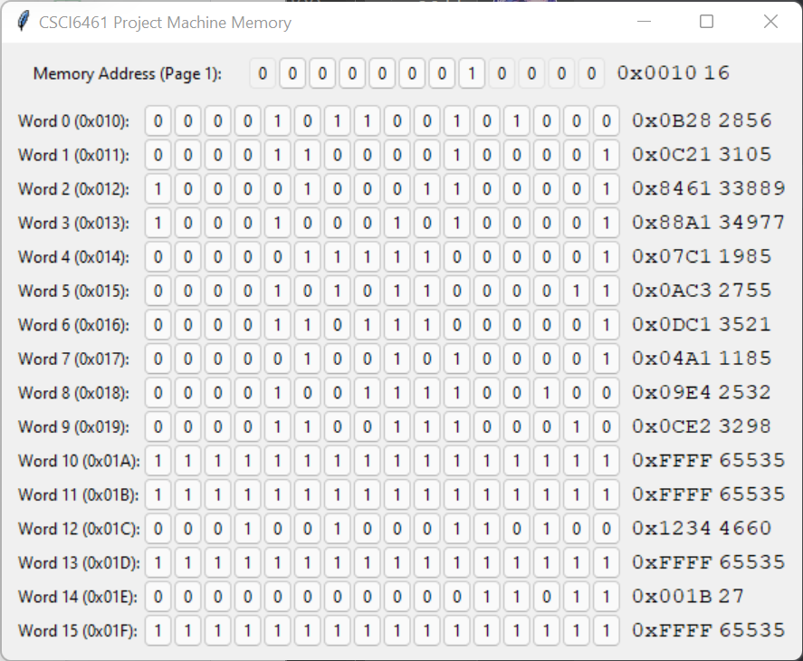

1. Imports: the module imports the external module “tkinter” and its submodule “ttk”, “filedialog” which are built-in to Python 3.7. It also imports “CSCI6461_Project_classes” and “CSCI6461_Project_data”.
2. Modules:
3. “memoryPage” frame at the top of the window is a single instance of labeledBitString “memoryPageNum” with the first one and last four buttons disabled, it functions as a page navigator showing the page number and the address of the currently shown memory locations. When the number in the navigator is changed by pressing the buttons, the frame below will be updated to show the words in the destination memory page.
4. “memoryCont” frame in the remaining parts of the window holds 16 labeledBitString instances “memoryEntry”, each of them holds the value to one 16-bit word in memory and displays its value and its word address.
5. Methods:
6. windowMemory_onClose() : Whenever the memory editor is closed this function gets triggered. It destroys and removes the record of the window and re-enables the button on the main interface for reopening the editor.
7. MemoryWrite(address) : This function is used to write values into a memory word from the memory editor. If the memory editor is not opened, it will not perform any operation.
8. MemoryPageUpdate(): This function is used to refresh the page when the memory editor’s page number changes. It calculates the new page number from “memoryPageNum” register, and iterates through each of the “memoryEntry” instances while setting their newly pointed-to address, new trigger functions to write to memory when their value changes, and change their display value to that currently stored in the memory.
9. ProgramLoad() : This function is used to load a text file to initialize values into memory. It will set GPR, IXR, PC,MAR,MBR,IR,MFR,CC,HALT as Zero (0). And read the uploaded file provided by the user. If the file is not readable or if it is not appropriate then it throws an exception otherwise it loads the provided hexadecimal value into memory. And call memoryPageUpdate function to reflect the changes on the GUI.
10. guiMemory() : This function creates the memory viewer/editor GUI window. The open button on the main interface will also be disabled to prevent opening multiple memory windows.
11. Creates a separate window to view/edit the memory named "CSCI6461 Project Machine Memory". data[windowMemory] is the main GUI window for memory. It splits into two further frames “memoryPage” & “memoryCont”.
12. if the window is closed, destroy it by calling windowMemory_onClose() function.
13. Configures the trigger functions dictionary within “memoryPageNum” to be able to update the memory content display when needed.

***Global Data.* CSCI6461_Project_data.py** is the script containing definition and initialization for a single variable named “data” to be used by the console and other modules, it will contain all information held by the program. This includes all of memory, all registers, and all gui elements. This module can be imported by itself, but without utilization from other modules, it is practically useless.

***Execution.* CSCI6461_Project_execution.py** is the script containing definitions for all instruction-related operations in the simulator program. Currently it only contains functions to execute HLT/LDR/LDA/LDX/STR/STX instructions, to throw machine faults, the function to be called when the “step” or “run” button is pressed on the main user interface, and helper functions to assist them. It is possible but not useful to import this module by itself.

1. Imports: It imports “CSCI6461_Project_gui_memory” , “CSCI6461_Project_data” and “CSCI6461_Project_classes” .
2. Methods:
   1. readFromMemory(address, indirect=False) : This function is used to get the value from memory and update/write the registers which are MAR and MBR accordingly and return the result.
   2. writeToMemory(address, value, indirect=False, checkReserve=True) : This function writes the value to address in memory, while updating MAR/MBR accordingly. It gets the effective memory address into MAR and tries to write the value to MBR and effective address in memory and calls memoryPageUpdate() to refresh the page.This function returns -(fault ID)-1 if fault occurs otherwise return 0.
   3. fault(id) : This function handles machine faults. It first sets the MFR in the main interface to the corresponding fault id, stores the erroneous PC to memory location 4, then loads the address at memory location 1 into PC so the machine can continue running.
   4. HLT() : This function stops the machine by setting the HALT register to 1.
   5. splitInstructionLoadStore(instruction) :Instruction is a 16-bit integer (0-65535).This function is used to split the 16-bit instruction into opcode(6), r(2), ix(2), i(1), address(5) in this order for load and store instructions.

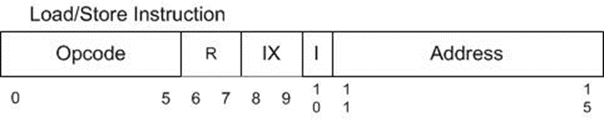

* 1. LoadStoreInstExec(instruction) : This function is used to execute load/store instructions (LDR/LDA/LDX/STR/STX). Initialize effective address (EA) and return value: if index register value is greater than zero then it adds address and IXR value to calculate EA. Furthermore, if it is LD instructions (LDR/LDA/LDX) then get Value From Memory by calling readFromMemory(EA, False) function into GPR and IXR. If opcode represents store instruction then it gets the value from GPR and IXR and writes the data into memory by calling writeToMemory(EA, value, indirect=i) function. This function returns read value if instruction is successfully loaded, returns 0 if instruction is successfully written and returns -(fault ID)-1 if any fault occurs.
  2. execute(instruction) : This function executes an instruction which is a 16-bit integer (0-65535). It returns true if executed normally and returns False if halted or faulted. Internally it checks the opcode if it is in [1,2,3,33,34] then calls LoadStoreInstExec(instruction) and returns true if it is 0 then it returns false.
  3. singleStep() : Get the value of PC and read the instruction using readFromMemory(address) function and check if instruction is executable then update IR and call execute(instruction) function. If the execute(instruction) function is successfully executed without any fault then it increases the PC by one.
  4. multiStep() : This function keeps calling singleStep until it stopped (i.e. HALT = 1)